This source code is licensed, not sold, and is subject to a written license agreement. Among other things, no portion of this source code may be copied, transmitted, disclosed, displayed, distributed, translated, used as the basis for a derivative work, or used, in whole or in part, for any program or purpose other than its intended use in compliance with the license agreement as part of the QualNet software. This source code and certain of the algorithms contained within it are confidential trade secrets of Scalable Network Technologies, Inc. and may not be used as the basis for any other software, hardware, product or service.

SCENARIO PURPOSE: 802.16 as a WAN transmission technology in QualNet and EXata

SCENARIO:

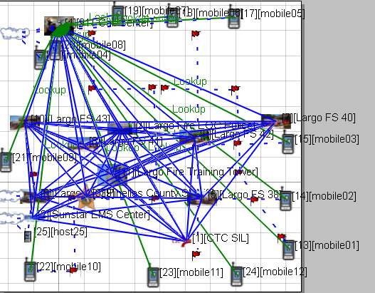

All the mobile units are in four wireless subnets and use 802.16 as a WAN transmission technology. Each Subnet listening to a unique channel. All the mobile units are exchanging data with the 911 call center using lookup. All the base stations tied together with a wired WAN.

APPLICATIONS:

LOOKUP 16 4 0 512 512 1S 1S 1S 0S

LOOKUP 20 4 0 512 512 1S 1S 1S 0S

LOOKUP 19 4 0 512 512 1S 1S 1S 0S

LOOKUP 18 4 0 512 512 1S 1S 1S 0S

LOOKUP 17 4 0 512 512 1S 1S 1S 0S

LOOKUP 15 4 0 512 512 1S 1S 1S 0S

LOOKUP 21 4 0 512 512 1S 1S 1S 0S

LOOKUP 14 4 0 512 512 1S 1S 1S 0S

LOOKUP 13 4 0 512 512 1S 1S 1S 0S

LOOKUP 24 4 0 512 512 1S 1S 1S 0S

LOOKUP 23 4 0 512 512 1S 1S 1S 0S

LOOKUP 22 4 0 512 512 1S 1S 1S 0S

DESCRIPTION OF THE FILES:-\

1. 802dot16FirstResponder.app - QualNet configuration file for application input.
2. 802dot16FirstResponder.config - QualNet configuration input file.
3. 802dot16FirstResponder.display - QualNet visualization parameters.
4. 802dot16FirstResponder.nodes - QualNet configuration file for node position.
5. 802dot16FirstResponder.expected.stat - QualNet statistics collection.
6. 802dot16FirstResponder.antenna-models – QualNet Antenna Configuration file.
7. default.antenna-azimuth – QualNet Antenna azimuth pattern file.
8. default.ascii3d - QualNet Antenna pattern file.
9. default.asciiazimuth - QualNet Antenna azimuth pattern file.
10. default.nsm - QualNet Antenna pattern file.
11. 802dot16FirstResponder README.docx – This File source.
12. 802dot16FirstResponder README.pdf – This file distributable.